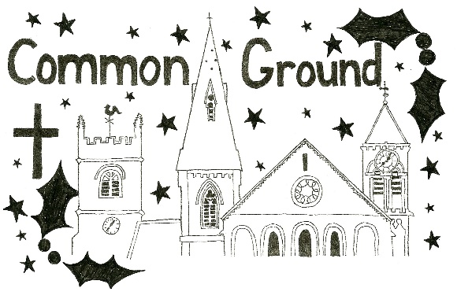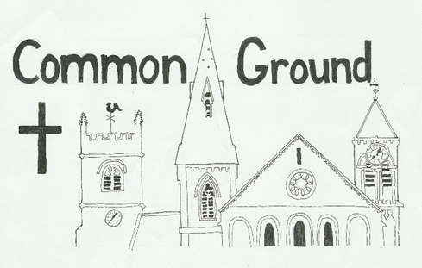The monthly magazine of the Church of England Benefice of

Rodborough, Woodchester and Brimscombe

**Issue 12 – December 2023/January 2024**

**Tis the season for…. Handel’s Messiah?**

Just the other day someone asked me where and when there was a Messiah production locally, because every year, in the run up to Christmas there are a number of productions of Handel’s Messiah.

But the Messiah isn’t just ‘Christmas music’ like Bing Crosby or Wizzard. The Messiah is not even just a sublime piece of music but a meditation on the life of Jesus, on who he is, what he has done and what it means to be his people. The message of the Messiah is not just about Jesus, it is about us and for us.

And the words to the Messiah are actually taken straight from the King James’ Bible (or in the case of the psalms from Coverdale’s translation that was used in the Book of Common Prayer). In other words, these were the scriptures that people were familiar with and heard, week in and week out at church and the versions of psalms they said and sung, but not put together like this is in a single narrative.

As I listened again, I was struck by the opening words of the Messiah, taken from one of the key advent passages (Isaiah 40): "Comfort ye, comfort ye my people, saith your God."

To listeners to the Messiah, this comes straight after the dramatic overture, but to readers of Isaiah this comes after the even more dramatic predictions of the fall of Israel and their captivity in Babylon. They had trusted everyone apart from God and their allies had failed them. Their city and temple are in ruins and they are now slaves in a foreign land, separated from homes and loved ones and for many their hopes and dreams are all gone.

Yet amidst their darkness, God had never abandoned them, though they abandoned him. Isaiah goes on to call them to prepare the way of the Lord, a preparation of their hearts and minds and lives for the coming King and his Kingdom.

There is light in the darkness, there is a holy and loving God who is present and with us and calls us into the light. He calls us to be lights in the world, to be a holy people - his people, to be working to build his Kingdom, and to these ends to be people transformed by the light, walking into a life in all its fullness.

This Christmas, I pray that you would know God’s presence, his light with you, even amidst the darkness and his transforming presence in your life, that you too may bring light.

Rev. Peter Francis

Rector of Rodborough, Woodchester & Brimscombe

**Note from the editor**

Hello again everyone

I can’t believe it’s now a whole year since I took on the task of pulling together the monthly Common Ground magazine. I would like to take this opportunity to express my sincere thanks to everyone who has supported me, provided updates and information, patiently put up with my nagging for content and also to those of you that have invested energy and shoe leather in delivering the magazines around our benefice.

As we go from one year to another, it’s an appropriate time to reflect and review, so I would welcome feedback from you all as to whether Common Ground is meeting your needs, suggestions as to how we can improve it or other changes you would like to see. Please do email me, ring me or grab me in church to let me know what you think.

This issue includes details of services in January (subject to change) as our next full issue will be the February one (available from the last week in January).

Wishing you all the best for Christmas and the New Year. Amongst the challenges of these modern Christmases I hope you may all find some peace and space to think about and be uplifted by the true meaning of that first Christmas.

All the very best to you all,

Alyson

**News of our sermon series for December and January**

**December Sermons: ‘Prepare the way of the Lord.’**

As we prepare for Christmas, we have just started a new sermon series, ‘Prepare the way of the Lord.’ This title is taken from the words of John the Baptist, who, quoting the prophet Isaiah, tells people to ‘Prepare the way of the Lord’ – a preparation of their hearts and minds and lives for the coming King and his Kingdom. So as we look at some of the traditional advent and Christmas readings we’ll be thinking about preparing our hearts, minds and lives for the coming King and his Kingdom.

**January Sermons: The Fear of the Lord …**

When the Bible mentions something again and again, we take note, or do we? Many of repeated phrases running through scripture are familiar to us, yet ‘the fear of the Lord’, despite its prominence in the Bible, rarely gets mentioned. It’s a phrase that we might not understand and fear is something we might want to avoid, but as we start the new year, we will be unpacking this important yet unknown biblical concept and looking at what it has to say to us today.

Rev. Peter Francis

Rector of Rodborough, Woodchester & Brimscombe

**New Benefice Service**

Just a reminder to everyone of our recently introduced weekly service, a Benefice Service of the Word, that takes place at Rodborough, every Wednesday at 1000. The service is held in Rodborough’s snug at the Old Endowed School by the church. The service is approximately 25 minutes in length followed by coffee and cake at Coffee Pot.

This is an ideal opportunity, especially in the run up to Christmas, to find a little peace, downtime and a chance to re-energise spiritually at what, for many, can be a stressful and challenging time of the year.

Everybody of any age is most welcome.

Please do come along and support this.

**Works at St Mary Woodchester**

We now have the go-ahead to open up the area at the bottom of the church tower to allow access for visitors wishing to see the Huntley monument and the stained-glass window. After a little more reorganising work this should be possible soon.

**Woodchester’s Wonderful Tuesday Gang**

Thanks to all the hard work of the Tuesday Gang, especially over a year when the grass seemed to never stop growing, our churchyard has been very lovingly cared for and maintained. The Tuesday Gang have put in so many hours to make this possible. On behalf of us all I would like to say a heartfelt thank you to them for all that they have done and continue to do; it is so very much appreciated.

**Looking back……………**

**Lee Abbey weekend 2023**

We are relatively new members of St Mary’s Woodchester having moved into the village about 18 months ago. Everyone has been very welcoming and when we heard about the church weekend, we thought it would be a good way to get to know others in the congregation better.

Lee Abbey is set in the wonderful scenery of the North Devon coast. We drove via Lynton through the stunning Valley of Rocks to find the house and grounds. We had a very comfortable room which looked right down to the bay and we could see the sea from our bedroom window.

Having not been to a church houseparty at Lee Abbey before we were not sure what to expect. We were given a programme of meetings and activities, but on arrival but there was plenty of free time and the meetings and worship were entirely optional. There was a regular supply of tea, coffee and cake to keep us going too!

The community who run Lee Abbey come from all over the world, as well as the UK, and members sat with us to serve and share the delicious meals that were cooked by the kitchen team. It was very interesting to talk with them and learn their stories as well as talking to our fellow guests from Woodchester, Brimscombe and Rodborough churches and from elsewhere.

The worship and teaching meetings were a little different from what we were used to but nonetheless were interesting and gave us food for thought. On Saturday morning there was a worship session with a talk followed by a time of reflection, either individually or in small groups. We particularly enjoyed the night prayer held in the candlelit chapel which was very peaceful and allowed some time for meditation.

Saturday afternoon was free and we took the opportunity to go out for a walk. Later we joined in an enjoyable games evening. Our team came 2nd to last, but a good time was had by all!

Sunday morning was Holy Communion with the community followed by a walk to the beach before lunch and time to depart. The weekend had flown by.

It was certainly a good way to get to know others better and to feel part of the church in Woodchester as well as to enjoy the beautiful surroundings and home cooked food. We plan to go again.

David and Jenny Warner

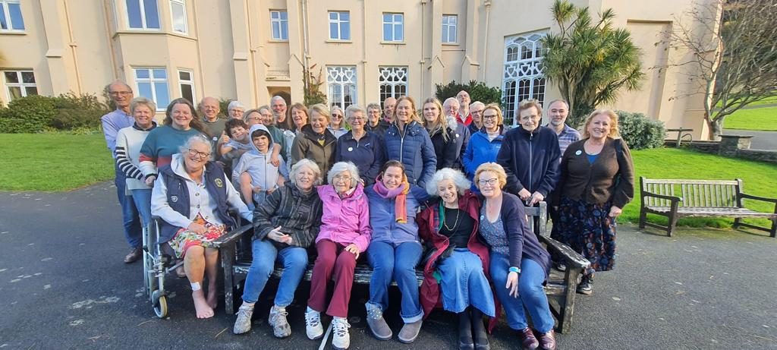

**Stop press……………….**

*As you read this another wonderful Lee Abbey weekend is being planned for 2025!!*

**Eco-Church Update**

**Good news** – on behalf of St Mary Woodchester I submitted our application for the Eco-Church Bronze Award and it was indeed awarded to us on 23rd October. Holy Trinity Brimscombe’s application is meanwhile “in the process” so we hope to hear more news soon.

Another “Eco Breakfast” took place in the Undercroft at Woodchester on November 18th. Here’s what we considered:

**Flowers in Church** - Jill Farrow reported back from a meeting she had attended in Minchinhampton, with Rosemary Pegler, about the need to move to “low carbon” practice with flower displays in church. The problems to overcome are (1) that the Oasis product used by flower arrangers, whilst very effective, is made of plastic and degrades into micro-plastics over time – we should not be buying any more but should revert to chicken wire (…has anyone got some old chicken wire to donate?) – and (2) that many cut flowers are either flown in by long-haul air freight or grown in heated greenhouses, and therefore have a big carbon footprint. We wondered when the habit of having flowers in church got started… and perhaps look forward to using only seasonal and local flowers and foliage: daffodils rather than lilies at Easter? Holly and ivy at Christmas? To be discussed with the arrangers in each church.

**Top tips for an Eco-Christmas** - we looked at the tips from various “green websites” and offer our readers these top five. There are plenty more if you search around on the internet.

1. **Present-wrapping and table decorations** – out with plastic! Use recycled paper and re-usable ribbon or string rather than shiny plasticised paper and Sellotape; or explore the Japanese craft of furoshiki, wrapping your presents in bits of material! If you have Christmas Crackers, get ones made of recycled/recyclable materials.
2. **Christmas Cards or emails**? An email, even with an image attached, uses on average a quarter of the carbon footprint of a card, when considering what it takes to produce and deliver. But a card is perhaps something which the recipient can enjoy for a longer time. Make your choice!
3. **Gifts** – around half UK adults say they have received a gift they don’t want – what a waste! Go for quality and careful choice, not quantity, and think about giving a (low-carbon) Experience rather than an Object?
4. **Christmas tree** – **real or artificial?** an artificial tree should have a life of at least 7 and ideally 20 years to outweigh the carbon footprint of a real tree. If you have a real tree, consider buying one in a pot that can survive and be used again next year – or hire one; don’t send it to landfill which will result in harmful methane emissions. Get it taken away for chipping if possible- and we think there will be a skip in Dr Browns Road, Minchinhampton, where you can drop yours off.
5. **Christmas Food** – cut down on the meat to reduce your carbon impact, and plan meals carefully to reduce waste!

We reminded ourselves of the joys of being with family at this time of year so don’t become Scrooges - **Have a Merry Christmas one and all!**

The next Eco Breakfast will be in Holy Trinity Brimscombe, on Saturday 13th January (9 for 9.30 a.m.)

Andrew Pemberton

**Squidgy Spiced Apple Cake**

By popular demand here’s the recipe for this cake that was enjoyed by many at November’s Lunch with Friends.

Ingredients:

* 125g butter
* 225g dark muscovado sugar
* 2 eggs (lightly beaten)
* 225g plain flour
* 2 tsp baking powder
* 2 tsp freshly grated nutmeg
* 1 tsp cinnamon
* 300g cooking apples (peeled, cored and diced)
* 2 tbsp clear honey
* 2 tbsp demerara sugar

Method:

Heat the oven to 160C/140C fan/gas mark 3.

Cream together the butter and muscovado sugar in a food processor or by hand then add the eggs.

Sift over the flour, baking powder and spices. Fold together, then stir in the apple.

Pour into a buttered, base-lined 20cm springform cake tin and bake for 1 hour or until risen and browned.

Combine the honey and demerara sugar and spread over the cake while still warm.

Remove the cake from the tin and serve with cream or ice cream. The cake will keep for 3-4 days wrapped in foil.

**Diary dates - Christmas events**

**LADIES’ CHRISTMAS CRAFT EVENING**

**Saturday 2nd December, 7 to 9.30pm, St. Mary’s Woodchester**

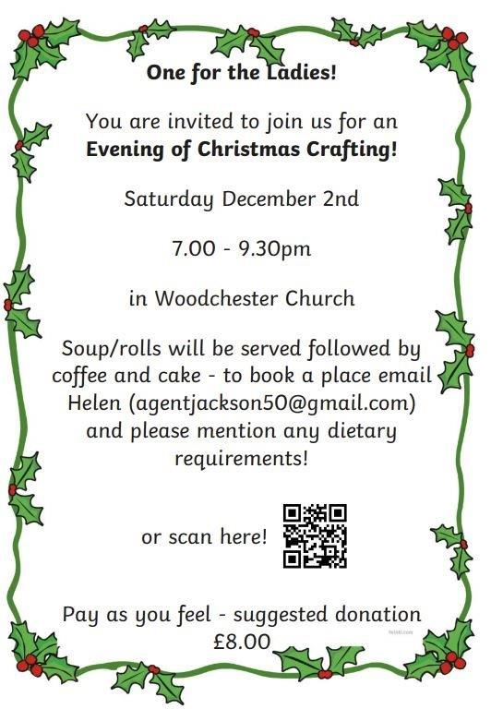

**Christmas events (continued)**

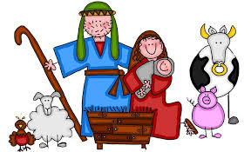

**ROVING NATIVITY**

**Sunday December 10th, 3.30pm** starting from Brimscombe School.

**CRIB SERVICE**

**Christmas Eve, 3pm, St Mary Woodchester**

We warmly invite everyone to our All-Age Crib Service which will be held on Christmas Eve at 3pm. This will be a short service in which the last hymn will be sung by candlelight. We invite youngsters to dress up as shepherds (tea towel), kings (crown), angels or an animal (animal mask). We also have lots of dressing up clothes in church. Please stay after the service for refreshments.

**And why not come Carolling………………**

**Community Coffee and Carol singing at the Long Table**

Tuesday 19th December, 11am

**Carols at the Coffee Pot, The Old Endowed School, Rodborough**

Wednesday 20th December, 10am until noon

**Woodchester Village Carols**

Wednesday 20th December, details below:

****South Woodchester

6.30pm Frogmarsh

6.50pm Tower House (no band)

North Woodchester

7.00pm Outside the Village Hall

All together

7.15pm In St Mary's church, with mince pies and mulled wine

**FAMILY MATTERS**

|  |  |  |  |
| --- | --- | --- | --- |
| ***WHAT*** | ***WHEN*** | ***WHERE*** | ***CONTACT*** |
| **LITTLE STARS**  - babies & toddlers | EVERY MONDAY, 9.30am  (in term time)  (up to and including 18th December, then restarting 8th January) | St Mary Woodchester | Elaine Penney 07974 208714  or Sue Pouncey 07866 487911 |
| **MESSY CHURCH**  - youngsters up to Year 6 accompanied by an adult  (free, activity filled session of crafts, music and stories with refreshment) | WEDNESDAY, monthly (in term time).  3.20pm – 4.45pm  Next meeting January 17th | St Mary Woodchester | Liz Hale liz@johnhale.plus.com |

**COMMUNITY**

|  |  |  |  |
| --- | --- | --- | --- |
| ***WHAT*** | ***WHEN*** | ***WHERE*** | ***CONTACT*** |
| **COFFEE POT**  (coffee, cake and good company, includes Benefice service of the Word in the Snug from 1000 to 1025 am) | EVERY WEDNESDAY 10am- noon  **(No meeting on 27th December)** | The Old Endowed School, Rodborough | John Atkinson jka1649@gmail.com |
| **COMMUNITY COFFEE MORNING**  (a chance to meet up with friends and our wider community over coffee and cake whilst supporting this local enterprise) | TUESDAY,  Monthly  11am  TUES 19th December (with carols!)  TUES 30th  January | The Long Table, Brimscombe | Jayne Hancock  07805 259246 |
| **LUNCH WITH FRIENDS**  (monthly gathering of senior members of the community to enjoy good conversation and company around a hearty home cooked meal) | FRIDAY, monthly  12.30  FRI 8th  December  12.00  FRI 19th  January | St Mary Woodchester | Liz Cole  07974 911016  Gail Birch  0787 5028671 |

|  |  |
| --- | --- |
| **Our Benefice: Prayer and Study Groups** | |
| **Monday Morning Prayer**  Each **Monday** at 9.00am  (not Bank Holidays) | Prayer on Zoom |
| **Monday Mums**  Each **Monday** at 12.30pm  (in term time, no meetings on Bank Holidays) | Location varies,  Contact: Sue Pouncey,  on 07866 487911 |
| **Prayer Group**  Each **Monday** at 7.30pm  (not Bank Holidays) | Holy Trinity, Brimscombe  Contact: Helen Kerr  on 07834 261278 |
| **Benefice Online Bible Study**  By Zoom, **Tuesdays** at 7.30pm  (please contact for details of break over the Christmas period) | Contact: Contact Peter Gee peter@pendragonuk.net or Victoria Robson victoria@thedoor.org.uk |
| **Prayer Group**  Each **Wednesday** from 7.30pm  (up to and including 13th December then restarting 10th January) | Location varies,  Contact: Gail Birch,  on 0787 5028671 |
| **Soul Food** Bible study and fellowship group meeting  **Alternate Thursdays**  (7th and 21st December; 4th and 18th January) | Brimscombe 1.00-2.15pm  Contact: Jenny Bernard on 07957 816313 |
| **Bible Study Group**  By Zoom, **Thursdays** at 7.30pm  (up to and including 14th December then restarting 4th January) | Contact: Andrew Pemberton on 07973 187923 |

**Sunday & Christmas Worship for December**

|  |  |  |
| --- | --- | --- |
| **Sunday 3rd**  *Advent 1* | 9.00am  11.00am  11.00am | Morning Worship Service at St Mary Magdalene, Rodborough  Morning Worship with creche and activities for older children at St Mary Woodchester  Morning Worship Service at Holy Trinity Brimscombe |
| **Sunday 10th**  *Advent 2* | 9.00am  11.00am  11.00am | Morning Worship Service at St Mary Magdalene, Rodborough  Morning Worship with creche and activities for older children at St Mary Woodchester  Holy Communion Service at Holy Trinity Brimscombe |
| **Sunday 17th**  *Advent 3* | 9.00am  11.00am  11.00am | Holy Communions Service at St Mary Magdalene, Rodborough  All Age Baptism Service with creche at St Mary Woodchester  Family Christingle Service at Holy Trinity, Brimscombe |

|  |  |  |
| --- | --- | --- |
| **Christmas Eve** | 3.00pm  4.00pm  6.30pm  6.30pm | Crib Service (with dressing up for children and adults), followed by mince pies, at St Mary Woodchester  Christingle Service at St Mary Magdalene, Rodborough  All Age Carol Service at Holy Trinity Brimscombe  All Age Candle-lit Carol Service at St Mary Woodchester |
| **Christmas Day** | 9.00am  10.30am  1100am | All Age Praise with Holy Communion at St Mary Magdalene, Rodborough  All Age Praise with Holy Communion at St Mary Woodchester  All Age Praise with Holy Communion at Holy Trinity Brimscombe |
| **Sunday 31st** | 1100am | Joint Benefice Service at St Mary Woodchester |

**Looking ahead……………..**

**Sunday Worship for January**

|  |  |  |
| --- | --- | --- |
| **Sunday**  **7th**  **Epiphany** | 9.00am  11.00am  11.00am | Morning Worship Service at St Mary Magdalene, Rodborough  Morning Worship with creche and activities for older children at St Mary Woodchester  Morning Worship at Holy Trinity Brimscombe |
| **Sunday**  **14th** | 9.00am  11.00am  11.00am | Morning Worship at St Mary Magdalene, Rodborough  Morning Worship Service with creche and activities for older children at St Mary Woodchester  Holy Communion at Holy Trinity Brimscombe, |
| **Sunday**  **21st** | 9.00am  11.00am  11.00am | Holy Communion at St Mary Magdalene, Rodborough  All Age Morning Worship Service with creche at St Mary Woodchester  Morning Worship Service at Holy Trinity Brimscombe, |
| **Sunday**  **28th** | 9.00am  11.00am  11.00am | Morning Worship Service at St Mary Magdalene, Rodborough  Holy Communion at St Mary Woodchester with creche and activities available for older children  Morning Worship Service at Holy Trinity Brimscombe, |

**A date for your diary…………….**

**'Making your money work for climate and nature’**

**Cotswold Club, 11, High St, Minchinhampton, GL6 9BN**

**7.00-9.00 pm on Wednesday 17th January 2024**

An evening of information (rather than advice) on green pensions, investment, current accounts, green mortgages, and local ways to invest in green projects etc.

Further details to follow in Minchinhampton Parish Magazine

**And finally………………………**

**CALLING ALL KNITTERS!**

If anyone gets bored of Christmas tv, frustrated by family members or wants to stop their hands from dipping into the chocolates then why not do some knitting?

It’s never too early to start some scarves, hats and gloves for our shoeboxes for next year.

All contributions would be very welcome and very much appreciated.

Thank you!

|  |  |  |
| --- | --- | --- |
| **Our Benefice – contact numbers** | | |
| Churchwardens | Rodborough: John Atkinson Woodchester: David Pouncey  Nick Ardagh-Walter  Brimscombe: Chris Short  Richard Kerr | 07792 714792  07974 403449  07484 284261  07552 223763  07974 207299 |
| Rector | Rev Peter Francis  (Rest days Tuesdays and Fridays)  Email:  Peterfrancis777@gmail.com | 07740 677645 |
| Readers | Richard Spencer  Victoria Robson  Peter Gee | 01453 872686  07824 806160  07796 180317 |

|  |  |
| --- | --- |
| **Common Ground monthly magazine**  **and weekly What’s On** | |
| Updates, news, event details, changes, errors etc. | Contact:  Alyson Rogers  on 0750 000 5140  aly2144@icloud.com |
| To be added to the distribution list for email or hard copy format | Contact:  Helen Jackson  cground101@gmail.com |

**ZOOM DETAILS for Prayer times and Services**

***Zoom app***: Meeting ID: **883 864 9918**    Passcode:  **blessed**

***Zoom Access by telephone:*** Dial 0330 088 5830 local rate number

* When asked for a meeting-id enter **883 864 9918** on the keypad, followed by **# -**You will be asked for participant-id but just type another **#** You may also be asked for a security code – enter **866912**

|  |
| --- |
| **Church opening times** |
| **Brimscombe:** Open daily 8am-6pm |
| **Woodchester:** Open daily 10am-4pm |
| **Rodborough**: Open Mon-Fri and Sun 10am-4pm |

*All details are, to the best of our knowledge, correct at the time of publication but please don’t hesitate to contact us with errors or additions.*

*Please see our weekly What’s Ons for updates.*